Student Name | G. Manasa
Student Registration Number | 241U1R3007 | Class &Section: DS-IIA
Study Level: UG/PG | UG | Year &Term: II & I
Subject Name | Digital Electronics

Name of the Assessment | Open lab test
Date of Submission | 22/09/2025

Open lab test
LG1
2.Design and implement F=(A+B)(C+D)

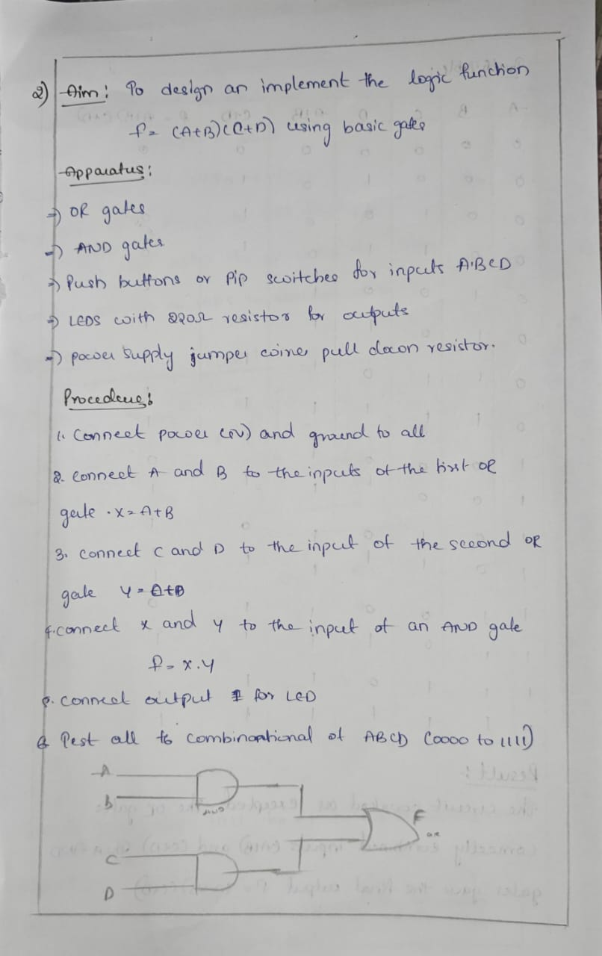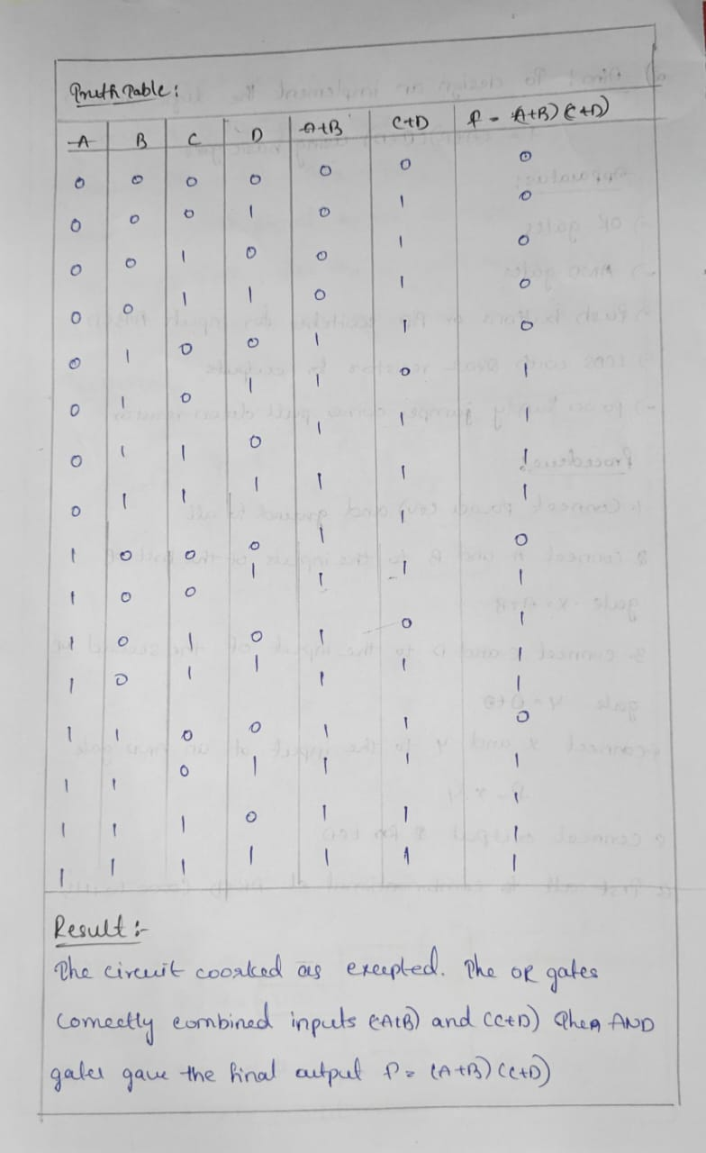

Simulation:

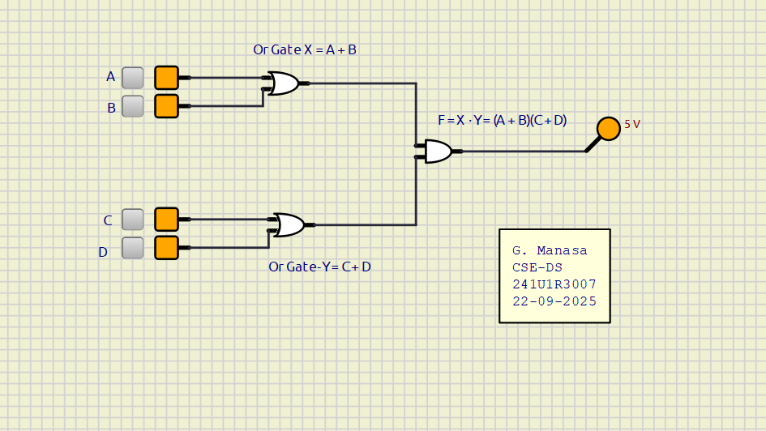

3.Design and implement 4-bit SIPO shift register
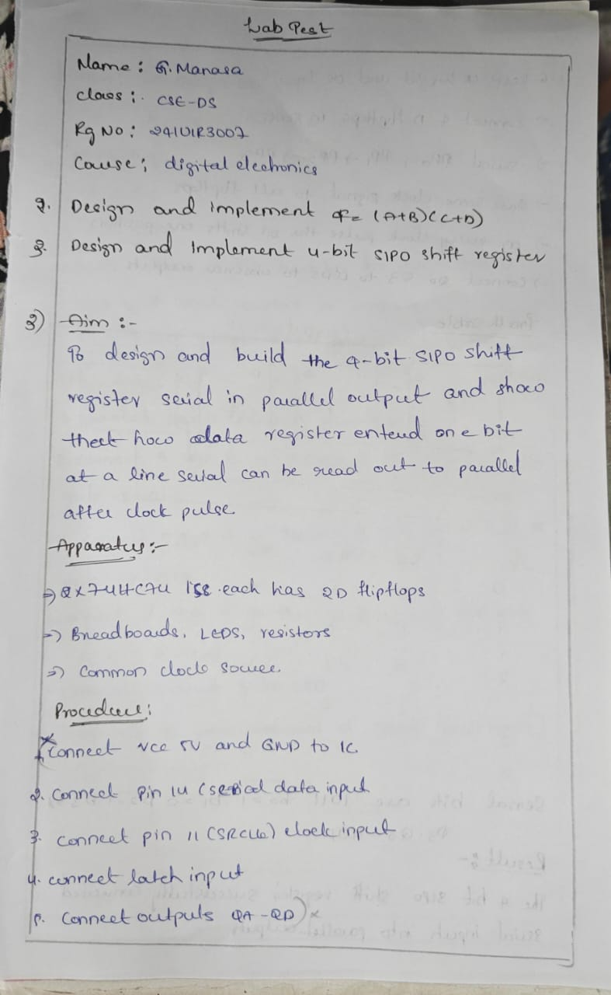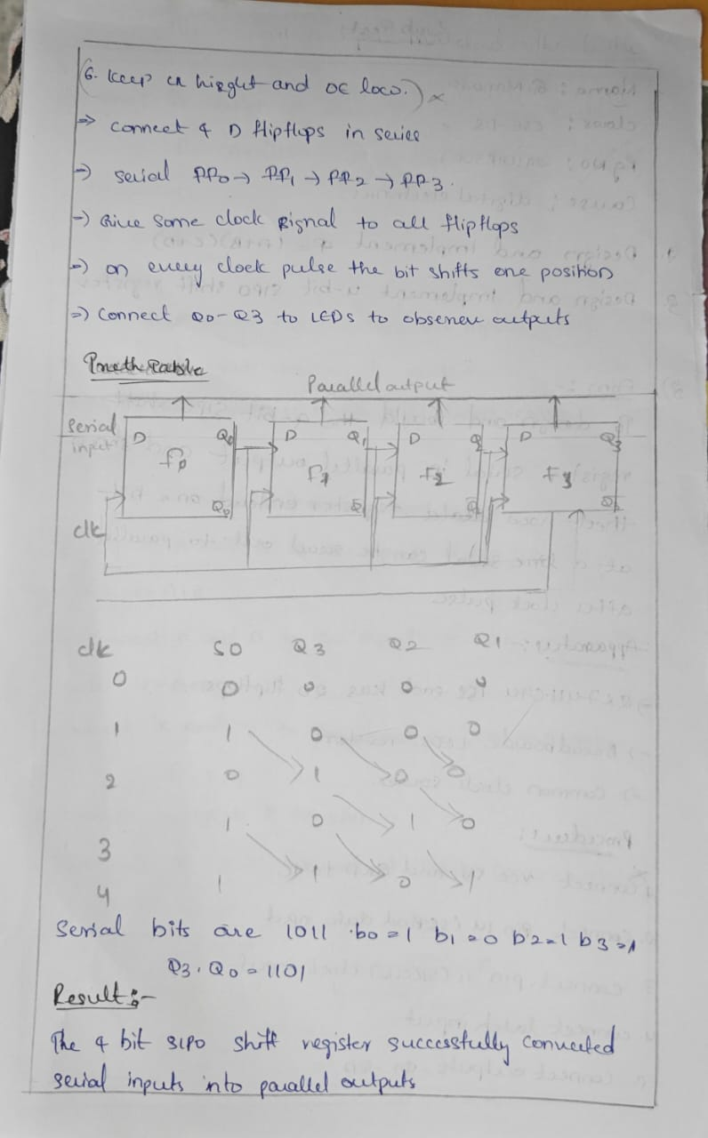

Simulation:

